**Online Figures for:**

**The recovery of European freshwater biodiversity has come to a halt**

**Authors:**

Peter Haase, Diana E. Bowler, Nathan J. Baker, Núria Bonada, Sami Domisch, Jaime R. Garcia Marquez, Jani Heino, Daniel Hering, Sonja C. Jähnig, Astrid Schmidt-Kloiber, Rachel Stubbington, Florian Altermatt, Mario Álvarez-Cabria, Giuseppe Amatulli, David Angeler, Gaït Archambaud, Iñaki Arrate Jorrín, Thomas Aspin, Iker Azpiroz, Iñaki Bañares, José Barquín Ortiz, Christian L. Bodin, Luca Bonacina, Roberta Bottarin, Miguel Cañedo-Argüelles, Zoltán Csabai, Thibault Datry, Elvira de Eyto, Alain Dohet, Gerald Dörflinger, Emma Drohan, Knut A. Eikland, Judy England, Tor E. Eriksen, Vesela Evtimova, Maria J. Feio, Martial Ferréol, Mathieu Floury, Maxence Forcellini, Marie Anne Forio, Riccardo Fornaroli, Nikolai Friberg, Jean-François Fruget, Galia Georgieva, Peter Goethals, Manuel A.S. Graça, Wolfram Graf, Kaisa-Leena Huttunen, Thomas C. Jensen, Richard K. Johnson, J. Iwan Jones, Jens Kiesel, Lenka Kuglerová, Aitor Larrañaga, Patrick Leitner, Lionel L'Hoste, Marie-Helène Lizée, Armin W. Lorenz, Anthony Maire, Jesús Alberto Manzanos Arnaiz, Brendan G. McKie, Andrés Millán, Don Monteith, Timo Muotka, John F. Murphy, Davis Ozolins, Riku Paavola, Petr Paril, Francisco J. Peñas, Francesca Pilotto, Marek Polasek, Jes Jessen Rasmussen, Manu Rubio, David Sánchez-Fernández, Leonard Sandin, Ralf B. Schäfer, Alberto Scotti, Longzhu Q. Shen, Agnija Skuja, Stefan Stoll, Michal Straka, Henn Timm, Violeta G. Tyufekchieva, Iakovos Tziortzis, Yordan Uzunov, Gea H. van der Lee, Rudy Vannevel, Emilia Varadinova, Gábor Várbíró, Gaute Velle, Piet F.M. Verdonschot, Ralf C.M. Verdonschot, Yanka Vidinova, Peter Wiberg-Larsen, Ellen A.R. Welti

**Table of Contents**

**Map of sampling durations**

* **Pg. 3:** Fig. 1 | Spatial variation in the number of sampling years across all 1,816 study sites.

**Maps of trends**

* **Pg. 4:** Fig. 2 | Spatial distribution of abundance trends.
* **Pg. 5:** Fig. 3 | Spatial distribution of trends in additional taxonomic diversity metrics.
* **Pg. 6:** Fig. 4 | Spatial distribution of trends in functional diversity metrics.
* **Pg. 7:** Fig. 5 | Spatial distribution of trends in additional functional diversity metrics.
* **Pg. 8:** Fig. 6 | Spatial distribution of trends in non-native and native species.
* **Pg. 9:** Fig. 7 | Spatial distribution of trends in EPT and insect taxa

**Response correlations**

* **Pg. 10:** Fig. 8 | Pearson’s correlations, histograms, and regression plots comparing all response variables.

**Maps of drivers**

* **Pg. 11:** Fig. 9 | Distribution of stream characteristics.
* **Pg. 12:** Fig. 10 | Distribution of land cover.
* **Pg. 13:** Fig. 11 | Distribution of dam impacts.
* **Pg. 14:** Fig. 12 | Distribution of climate variation.

**Driver correlations**

* **Pg. 15:** Fig. 13 | Pearson’s correlations, histograms, and regression plots comparing all stream characteristics and environmental driver variables.

**Meta-analysis sensitivity checks**

* **Pg. 16:** Fig. 14 | Sensitivity check to examine effects of years sampled on biodiversity trend estimates.
* **Pg. 17:** Fig. 15 | Sensitivity check to examine effects of the first sampling year (start year) on biodiversity trend estimates.
* **Pg. 18:** Fig. 16 | Comparison of trend estimates between meta-analysis models.
* **Pg. 19:** Fig. 17 | Jackknife analysis of trend estimates with countries removed.
* **Pg. 20:** Fig. 18 | Distribution over time for sites of a given taxonomic resolution.

**Moving window sensitivity checks**

* **Pg. 21:** Fig. 19 | Distribution over time of sites per country in moving window analysis.
* **Pg. 22:** Fig. 20 | Distribution over time for sites of a given taxonomic resolution in moving window analysis.
* **Pg. 23:** Fig. 21 | Estimates of the effect of year on trends in moving window analysis.
* **Pg. 24:** Fig. 22 | High threshold moving window analysis.
* **Pg. 25:** Fig. 23 | Moving window analysis of sites with species level community resolution.
* **Pg. 26:** Fig. 24 | Proportion of sites with positive taxon richness trends in moving window analysis by country.
* **Pg. 27:** Fig. 25 | Proportion of sites with positive abundance trends in moving window analysis by country.
* **Pg. 28:** Fig. 26 | Proportion of sites with positive functional richness trends in moving window analysis by country.
* **Pg. 29:** Fig. 27 | Proportion of sites with positive functional redundancy trends in moving window analysis by country.

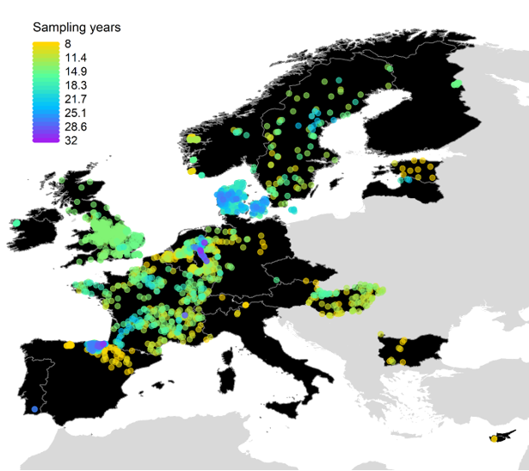

**Fig. 1 | Spatial variation in the number of sampling years across all 1,816 study sites.** Color of points shows the number of sampling years for each time series.

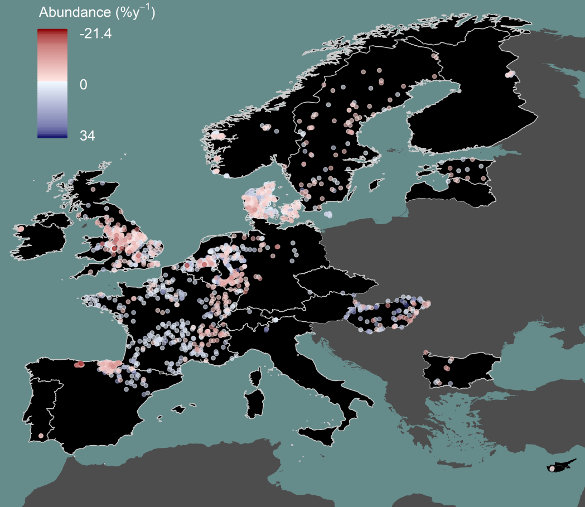

**Fig. 2 | Spatial distribution of abundance trends.** Point colors represent site-specific abundance trends in percentage change per year.

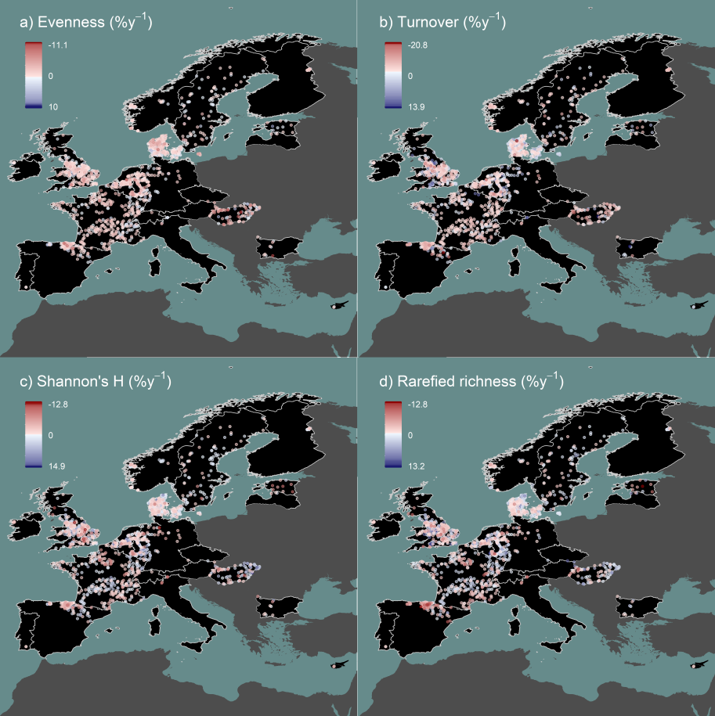

**Fig. 3 | Spatial distribution of trends in additional taxonomic diversity metrics.** Point colors represent site trends in percentage change per year for **a)** Shannon’s evenness, **b)** taxonomic turnover, **c)** Shannon’s diversity (H), and **d)** rarefied taxon richness.

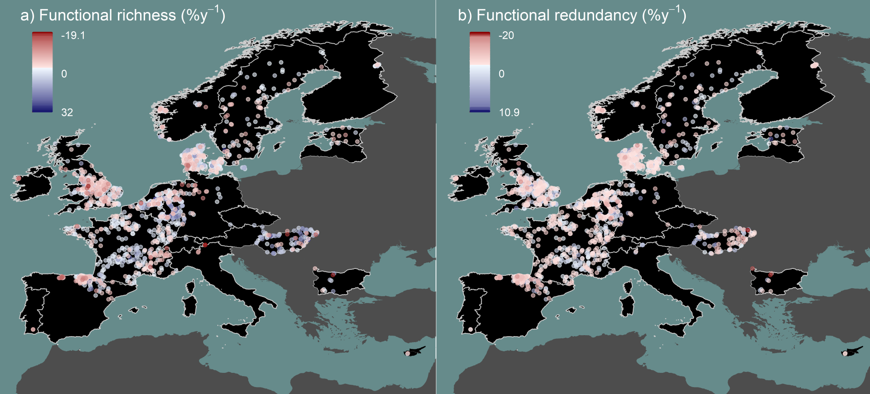

**Fig. 4 | Spatial distribution of trends in functional diversity metrics.** Point colors represent site trends in percentage change per year for **a)** functional richness and **b)** functional redundancy.

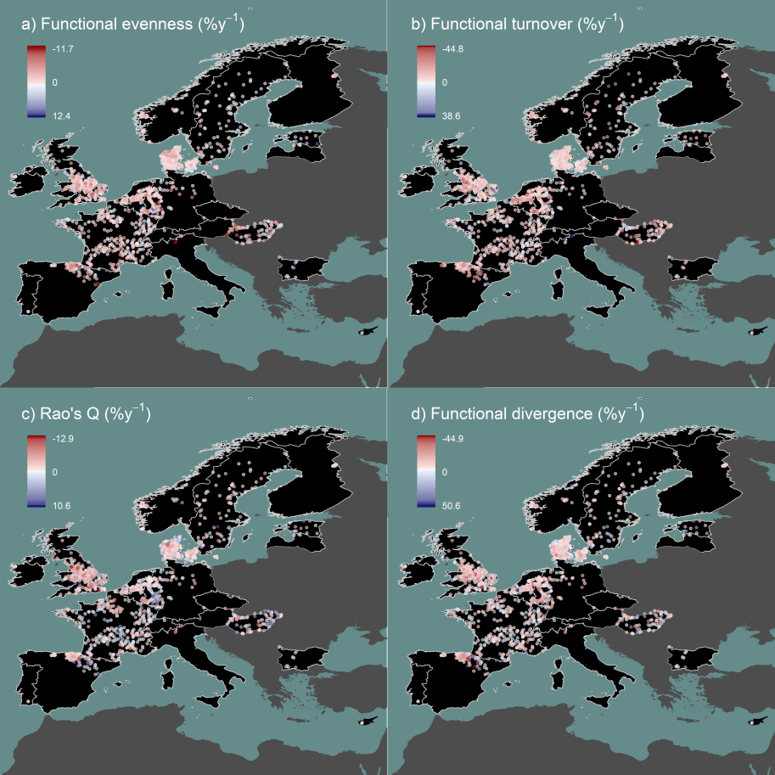

**Fig. 5 | Spatial distribution of trends in additional functional diversity metrics.** Point colors represent site trends in percentage change per year for **a)** functional evenness, **b)** functional turnover, **c)** Rao’s quadratic entropy, and **d)** functional divergence.

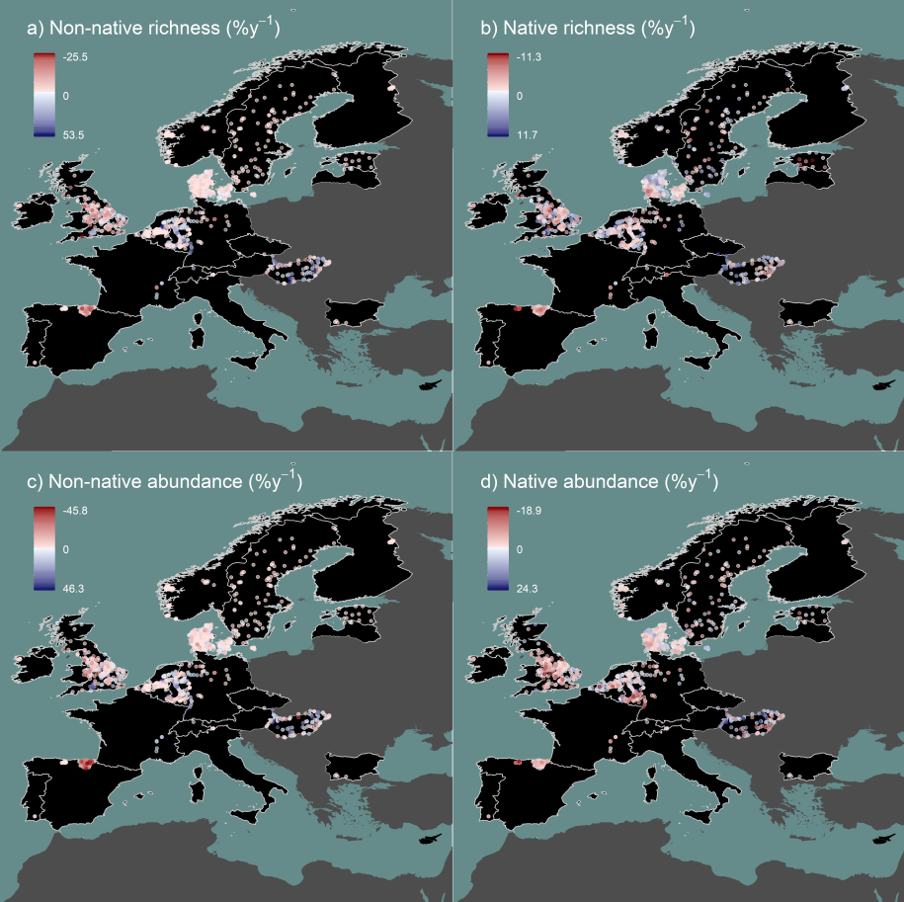

**Fig. 6 | Spatial distribution of trends in non-native and native species.** Point colors represent site trends in percentage change per year for **a)** non-native taxon richness, **b)** native taxon richness, **c)** non-native abundance, and **d)** native abundance. Only the 1,299 sites having high taxonomic resolution enabling identification of native versus non-native species are shown.

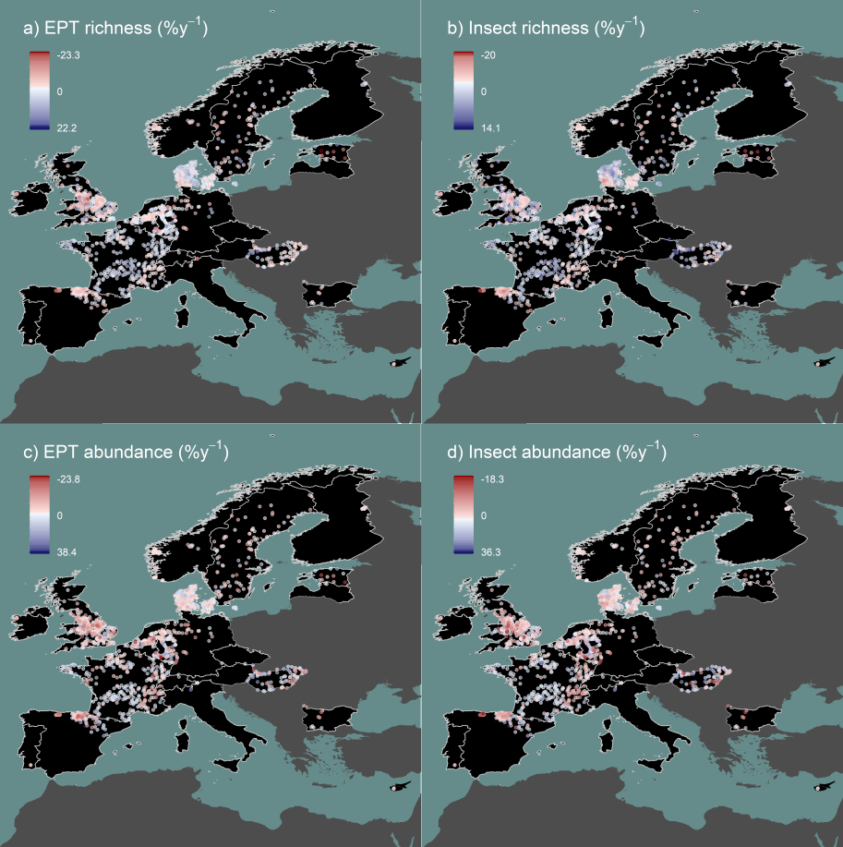

**Fig. 7 | Spatial distribution of trends in EPT and insect taxa.** Point colors represent site trends in percentage change per year for **a)** EPT taxon richness, **b)** insect taxon richness, **c)** EPT abundance, and **d)** insect abundance.

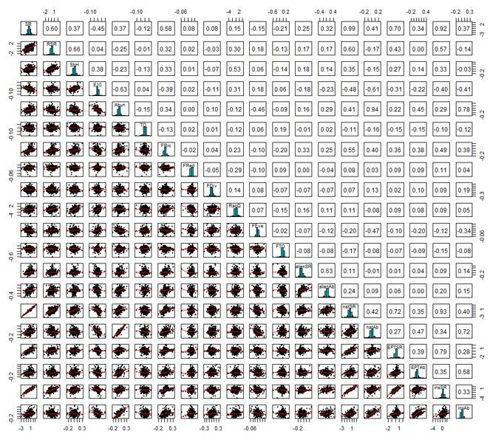

**Fig. 8 | Pearson’s correlations, histograms, and regression plots comparing all response variables.** SR = taxon richness, RSR = rarefied taxon richness, ShH = Shannon’s diversity (H), E10 = Shannon’s evenness, Abund = abundance, TO = taxonomic turnover, FRic = functional richness, FRed = functional redundancy, FDiv = functional divergence, RaoQ = Rao’s quadratic entropy, FEve = functional evenness, FTO = functional turnover, alienSR = non-native species richness, alienAb = non-native abundance, natSR = native taxon richness, natAb = native abundance, EPTSR = EPT taxon richness, EPTAb = EPT abundance, insSR = insect taxon richness, and insAb = insect abundance.

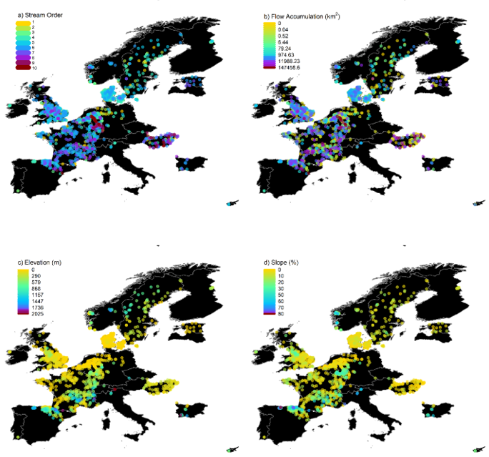

**Fig. 9 | Distribution of stream characteristics.** Spatial variation across the 1,816 study sites in **a)** Strahler stream order, **b)** flow accumulation, **c)** elevation, and **d)** slope. See Extended Data Table 4 for more details and sources of environmental data.

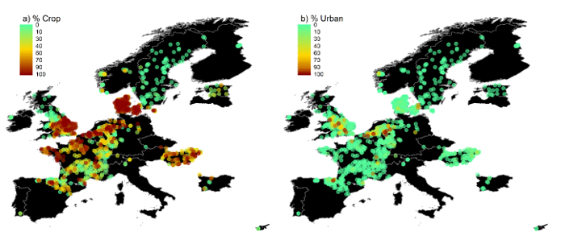

**Fig. 10 | Distribution of land cover.** Spatial variation across the 1,816 study sites in percentage upstream **a)** crop and **b)** urban land cover types. See Extended Data Table 4 for details and sources of environmental data.

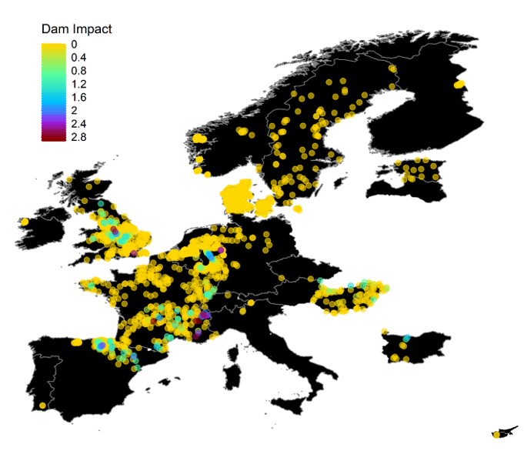

**Fig. 11 | Distribution of dam impacts.** Spatial variation across the 1,816 study sites in dam impact score based on distances between sites and upstream dams. See Extended Data Table 4 for details and the source of dam data and Methods for calculation of dam impact scores.

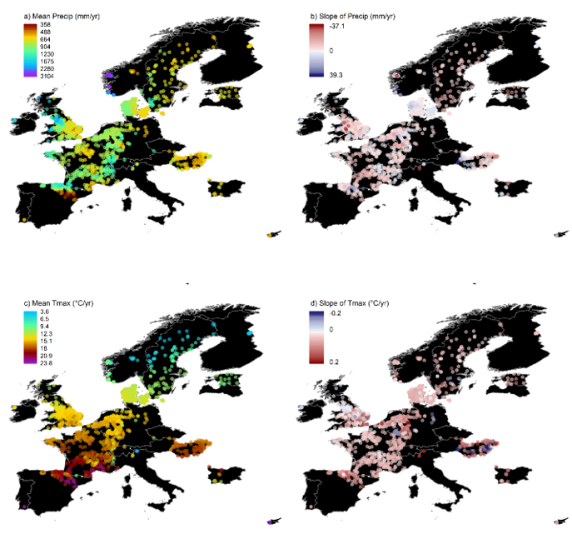

**Fig. 12 | Distribution of climate variation.** Spatial variation across the 1,816 sites and over study duration for **a)** mean cumulative annual precipitation, **b)** the change (trend) in annual precipitation per year, **c)** mean annual maximum temperature, and **d)** the change (trend) in annual mean maximum temperature per year. See Extended Data Table 4 for details and sources of climate data and the Methods for additional description of the calculations.

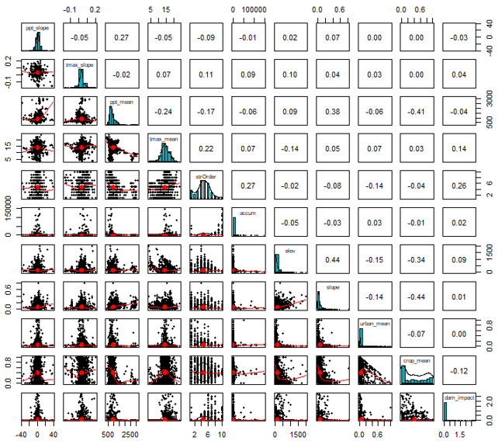

**Fig. 13 | Pearson’s correlations, histograms, and regression plots comparing all stream characteristics and environmental driver variables.** ppt_slope = the change (trend) in annual precipitation per year, tmax_slope = the change (trend) in annual mean maximum temperature per year, ppt_mean = mean annual cumulative precipitation, tmax_mean = mean annual maximum temperature, strOrder = Strahler stream order, accum = flow accumulation, elev = elevation, slope = slope, urban_mean = percentage upstream urban land cover, crop_mean = percentage upstream crop land cover, dam_impact = dam impact score. See Extended Data Table 4 and Methods for additional information on environmental data sources and processing.



**Fig. 14 | Sensitivity check to examine effects of years sampled on biodiversity trend estimates.** Points falling in the grey polygon indicate negative trends. The red line shows the linear regression relationship between number of years sampled and estimates and the 95% CI are shown as a pink polygon.



**Fig. 15 | Sensitivity check to examine effects of the first sampling year (start year) on biodiversity trend estimates.** Points falling in the grey polygon indicate negative trends. The red line shows the linear regression relationship between the first sampling year sampled and estimates and the 95% CI are shown as a pink polygon.



**Fig. 16 | Comparison of trend estimates between meta-analysis models.** Model estimates were comparable across model types including **a,** Weighted Meta-analysis: the model type used and described in the main manuscript where estimates are weighted by their uncertainty, **b,** Unweighted Meta-analysis: a two stage meta-analysis with no incorporation of uncertainty, and **c,** One Stage: a hierarchical model including site identity as a random term. Scripts including model formulas can be found at https://github.com/Ewelti/EuroAquaticMacroInverts in the “R” folder.



**Fig. 17 | Jackknife analysis of trend estimates with countries removed.** Model estimates of trends for taxonomic and functional response variables with each country sequentially removed. The removed country is labeled on the y-axis. Jackknife script including model formula can be found at https://github.com/Ewelti/EuroAquaticMacroInverts under “R/ HPC_Meta_analysis_country_jacknife.R”.



**Fig. 18 | Distribution over time for sites of a given taxonomic resolution.** Number of sites per taxonomic resolution (species, genus/mixed, family) included in each year across the study duration.



**Fig. 19 | Distribution over time for sites per country in moving window analysis.** Number of sites per country included in moving window from windows of 1990-1999 to 2011-2020 with x-axis showing mean year of each window.



**Fig. 20 | Distribution over time for sites of a given taxonomic resolution in moving window analysis.** Number of sites per taxonomic resolution (species, genus/mixed, family) included in moving window from windows of 1990-1999 to 2011-2020 with x-axis showing mean year of each window.



**Fig. 21 | Estimates of the effect of year on trends in moving window analysis.** Estimates of the effect of year on moving window trends of **a**, taxon richness, **b**, abundance, **c**, functional richness, and **d**, functional redundancy. Error bars around model estimates indicate 80%, 90%, and 95% credible intervals. The negative estimates found for taxon and functional richness indicate a reduction in trends over time (i.e. a shift from positive trends with windows in the 1990s to net zero trends for windows in the 2010s). Estimates corresponded to an average reduction of 8.8% y-1 in taxon richness trends and a reduction of 5.9% y-1 in functional richness trends. Overlapping error bars of estimates for abundance and functional redundancy indicate no strong linear change in trend trajectories. See Figure 3 in the main manuscript for change in moving window trends over time.



**Fig. 22 | High threshold moving window analysis.** Trends in **a**, taxon richness, **b**, abundance, **c**, functional richness, and **d**, functional redundancy over time from sites with ≥ 20 years of sampling between the years 1990-2020, the period most represented in our dataset. This analysis included 308 sites from 8 countries. Years were included when they represented a minimum of 200 sites. Estimates were calculated from Bayesian mixed-effects models of trends with ≥ 6 years within 10-year moving windows (windows 1992-2001 to 2011-2020; windows prior to 1994 had fewer than 200 sites and were not included). Years on the x-axis represent the mean year of each window. Gray polygons indicate 80, 90, and 95% credible intervals.



**Fig. 23 | Moving window analysis of sites with species level community resolution.** Trends in **a**, taxon richness, **b**, abundance, **c**, functional richness, and **d**, functional redundancy over time from sites with communities sorted to species level resolution. This analysis included 717 sites from 14 countries. Years were included when they represented a minimum of 200 sites. Estimates were calculated from Bayesian mixed-effects models of trends with ≥ 6 years within 10-year moving windows (windows 1994-2003 to 2011-2020; windows prior to 1994 had fewer than 200 sites and were not included). Years on the x-axis represent the mean year of each window. Gray polygons indicate 80, 90, and 95% credible intervals.



**Fig. 24 | Proportion of sites with positive taxon richness trends in moving window analysis by country.** Change in number of sites with positive versus negative trends (in black) in moving window analysis of taxon richness for each country: **a**, Austria, **b**, Belgium, **c**, Bulgaria, **d**, Cyprus, **e**, Denmark, **f**, Estonia, **g**, Finland, **h**, France, **i**, Germany, **j**, Hungary, **k**, Ireland, **l**, Italy, **m**, Latvia, **n**, Luxembourg, **o**, Netherlands, **p**, Norway, **q**, Portugal, **r**, Spain, **s**, Sweden, and **t**, United Kingdom. Blue points and lines show total sites included in each window. Values of 0.5 indicate equal number of sites with positive and negative trends, values >0.5 = more sites with positive versus negative trends, and values <0.5 = less sites with positive versus negative trends.



**Fig. 25 | Proportion of sites with positive abundance trends in moving window analysis by country.** Change in number of sites with positive versus negative trends (in black) in moving window analysis of abundance for each country: **a**, Austria, **b**, Belgium, **c**, Bulgaria, **d**, Cyprus, **e**, Denmark, **f**, Estonia, **g**, Finland, **h**, France, **i**, Germany, **j**, Hungary, **k**, Ireland, **l**, Italy, **m**, Latvia, **n**, Luxembourg, **o**, Netherlands, **p**, Norway, **q**, Portugal, **r**, Spain, **s**, Sweden, and **t**, United Kingdom. Blue points and lines show total sites included in each window. Values of 0.5 indicate equal number of sites with positive and negative trends, values >0.5 = more sites with positive versus negative trends, and values <0.5 = less sites with positive versus negative trends.



**Fig. 26 | Proportion of sites with positive functional richness trends in moving window analysis by country.** Change in number of sites with positive versus negative trends (in black) in moving window analysis of functional richness for each country: **a**, Austria, **b**, Belgium, **c**, Bulgaria, **d**, Cyprus, **e**, Denmark, **f**, Estonia, **g**, Finland, **h**, France, **i**, Germany, **j**, Hungary, **k**, Ireland, **l**, Italy, **m**, Latvia, **n**, Luxembourg, **o**, Netherlands, **p**, Norway, **q**, Portugal, **r**, Spain, **s**, Sweden, and **t**, United Kingdom. Blue points and lines show total sites included in each window. Values of 0.5 indicate equal number of sites with positive and negative trends, values >0.5 = more sites with positive versus negative trends, and values <0.5 = less sites with positive versus negative trends.



**Fig. 27 | Proportion of sites with positive functional redundancy trends in moving window analysis by country.** Change in number of sites with positive versus negative trends (in black) in moving window analysis of functional redundancy for each country: **a**, Austria, **b**, Belgium, **c**, Bulgaria, **d**, Cyprus, **e**, Denmark, **f**, Estonia, **g**, Finland, **h**, France, **i**, Germany, **j**, Hungary, **k**, Ireland, **l**, Italy, **m**, Latvia, **n**, Luxembourg, **o**, Netherlands, **p**, Norway, **q**, Portugal, **r**, Spain, **s**, Sweden, and **t**, United Kingdom. Blue points and lines show total sites included in each window. Values of 0.5 indicate equal number of sites with positive and negative trends, values >0.5 = more sites with positive versus negative trends, and values <0.5 = less sites with positive versus negative trends.